2403a51274

Name-Swamy

BATCH-12
AI ASSISTED CODING ASSIGNMENT-9.2

Task Description #1 (Documentation – Google-Style Docstrings for Python Functions)
- Task: Use AI to add Google-style docstrings to all functions in a given Python script.
- Instructions:
- Prompt AI to generate docstrings without providing any input-output examples.
- Ensure each docstring includes:
- Function description
- Parameters with type hints
- Return values with type hints
- Example usage
- Review the generated docstrings for accuracy and formatting.
- Expected Output #1:
- A Python script with all functions documented using correctly formatted Google-style docstrings.

PROMPT:
Task: Add Google-style docstrings to all functions in this file. Requirements:
- Include function description
- Parameters with type hints
- Return values with type hints
- Example usage
- Do not include input/output examples other than Example section.

Code and Output:
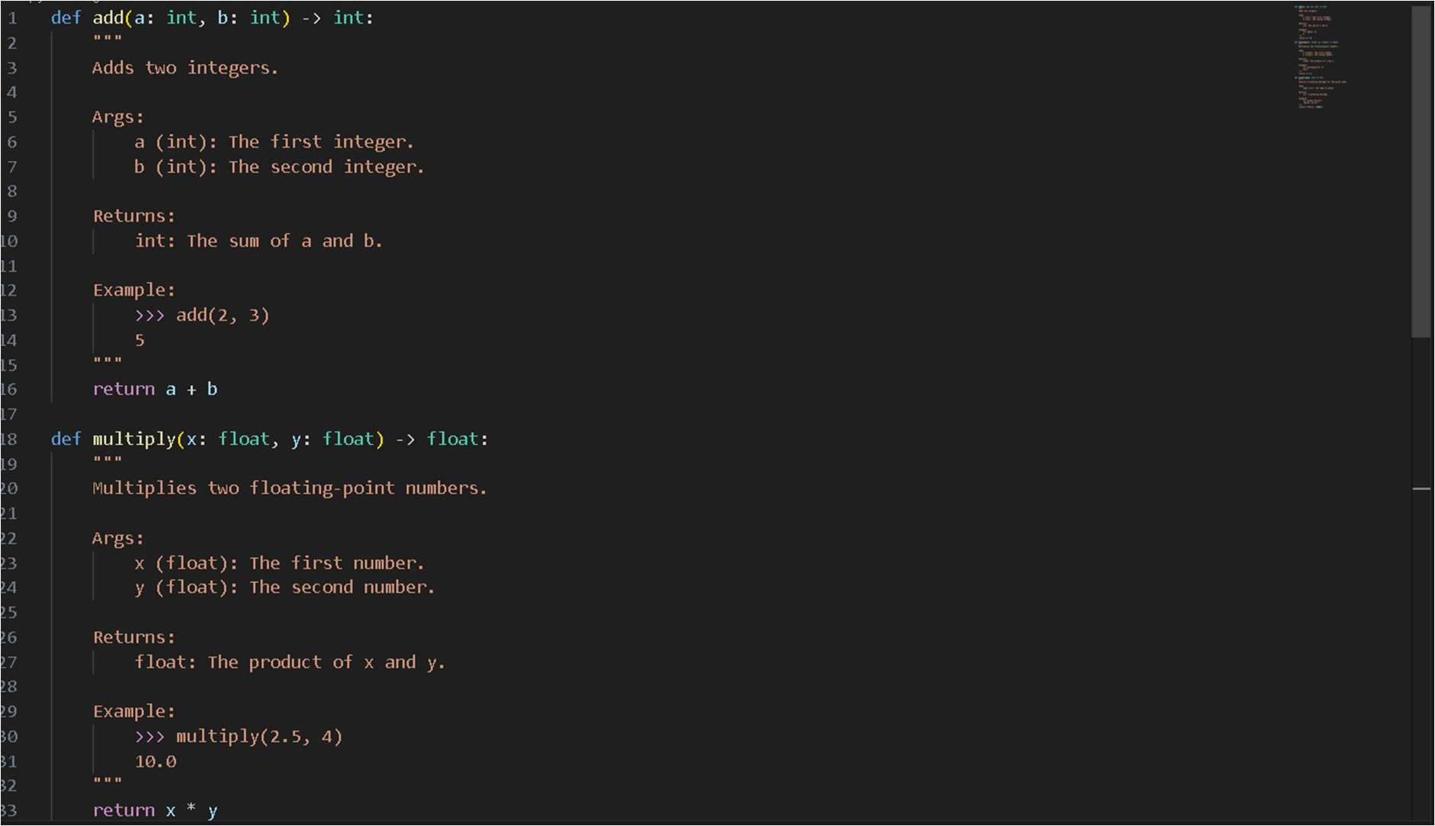
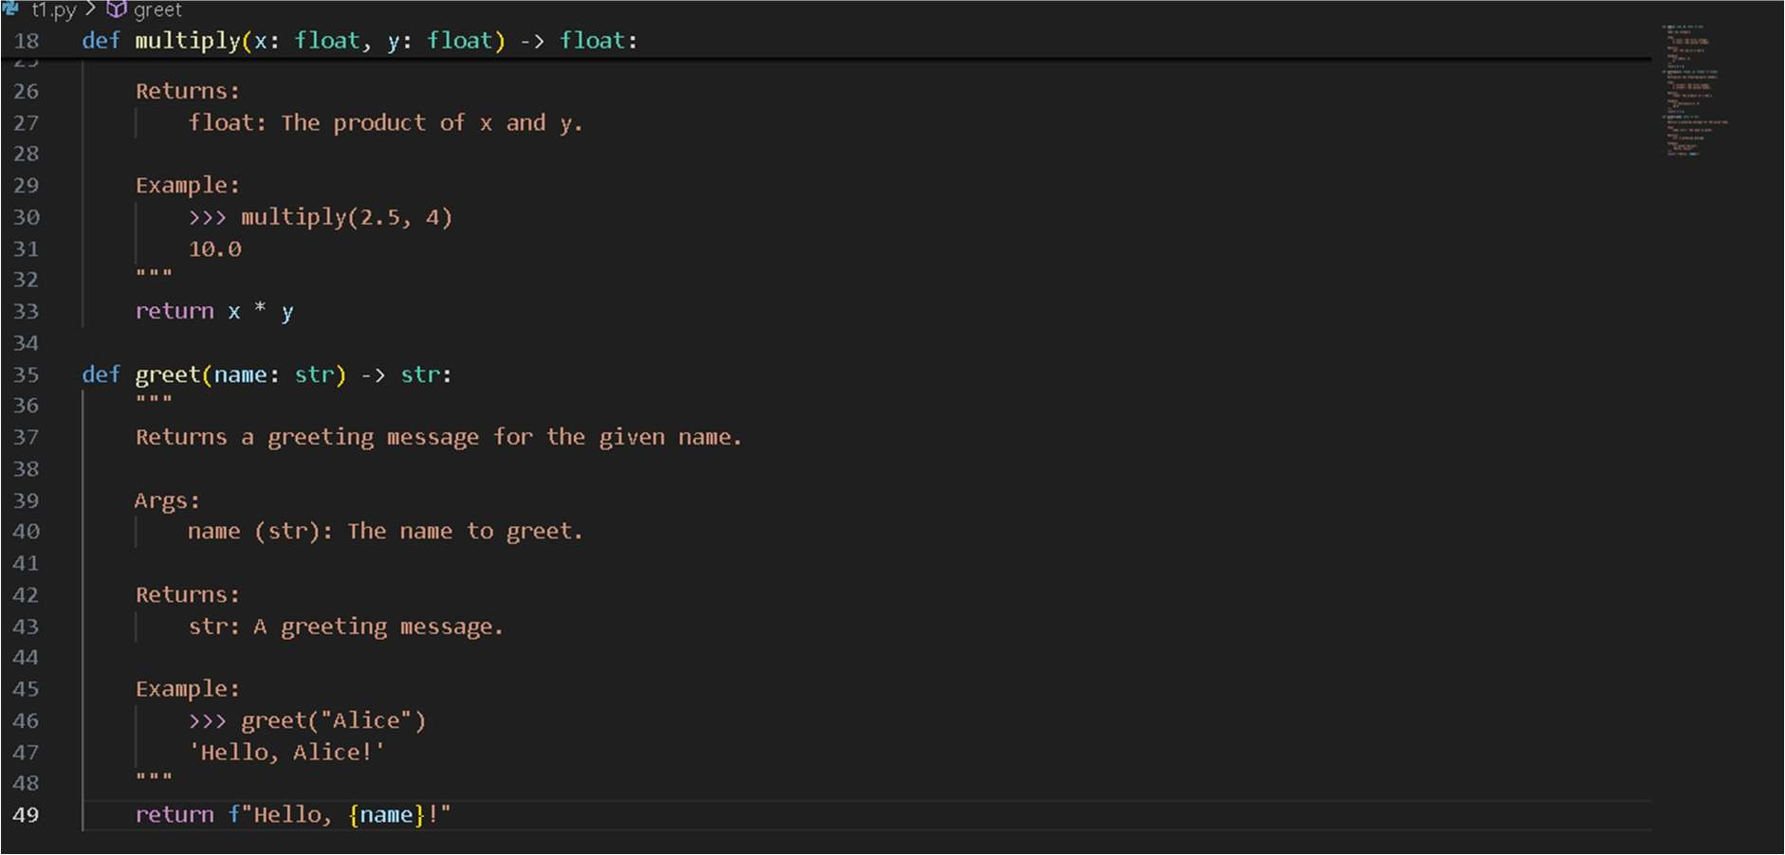

Task Description #2 (Documentation – Inline Comments for Complex Logic)
- Task: Use AI to add meaningful inline comments to a Python program explaining only complex logic parts.
- Instructions:
- Provide a Python script without comments to the AI.
- Instruct AI to skip obvious syntax explanations and focus only on tricky or non-intuitive code sections.
- Verify that comments improve code readability and maintainability.

- Expected Output #2:
- Python code with concise, context-aware inline comments for complex logic blocks.

Prompt:
Task: Add meaningful inline comments to this Python program. Instructions for AI (Copilot):
- Focus on complex or non-intuitive logic blocks only.
- Skip obvious syntax explanations (like variable assignments or basic loops).
- Comments should improve readability and maintainability of the code.

Code and Output:
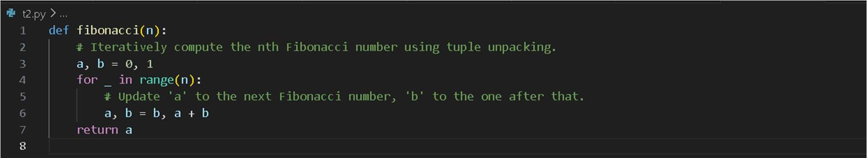
Task Description #3 (Documentation – Module-Level Documentation)
- Task: Use AI to create a module-level docstring summarizing the purpose, dependencies, and main functions/classes of a Python file.
- Instructions:
- Supply the entire Python file to AI.
- Instruct AI to write a single multi-line docstring at the top of the file.
- Ensure the docstring clearly describes functionality and usage without rewriting the entire code.
- Expected Output #3:
- A complete, clear, and concise module-level docstring at the beginning of the file

Prompt:
Task: Create a module-level docstring summarizing the purpose, dependencies, and main functions/classes of this Python file.
Instructions for AI (Copilot):
- Write a single multi-line docstring at the very top of the file.

- Clearly describe the module’s functionality and usage.
- Include dependencies (imports), main functions, and classes.
- Do not rewrite or duplicate the entire code.

Code and output:

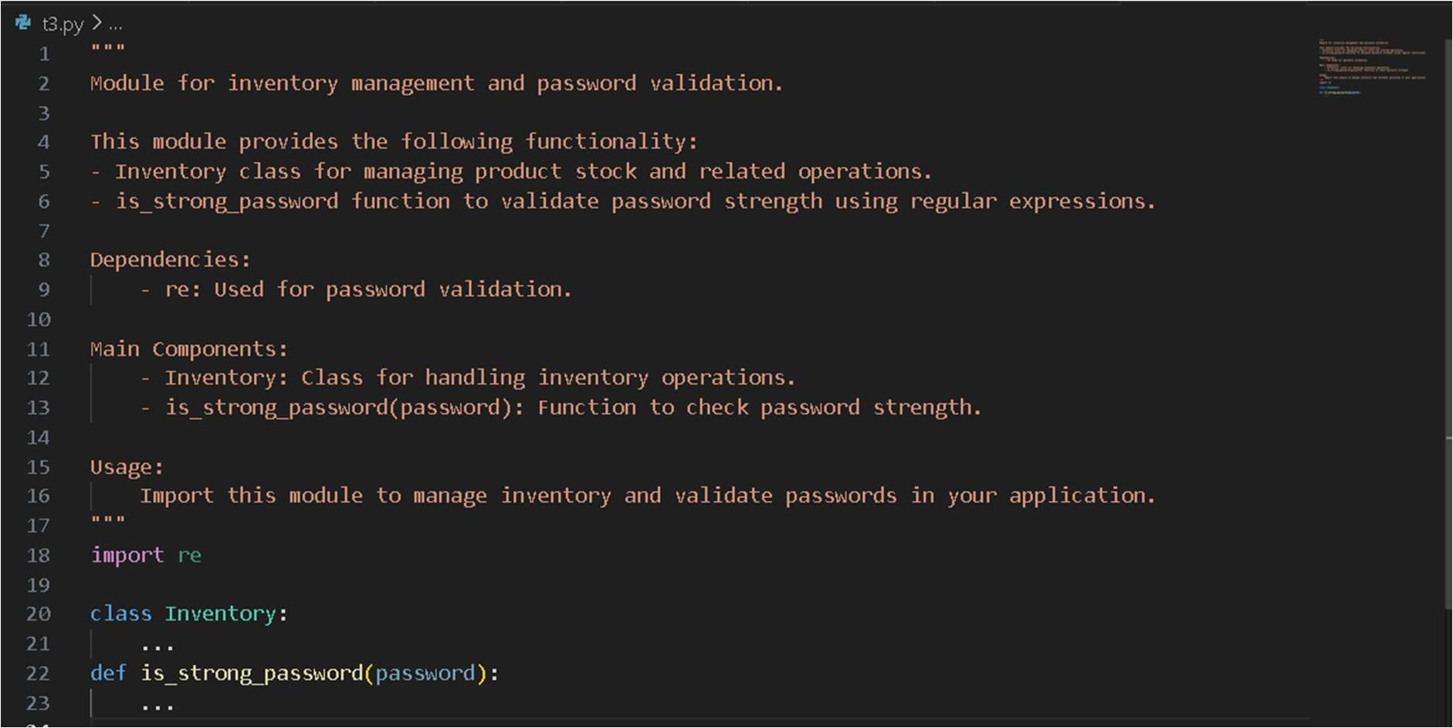
Task Description #4 (Documentation – Convert Comments to Structured Docstrings)
- Task: Use AI to transform existing inline comments into structured function docstrings following Google style.
- Instructions:
- Provide AI with Python code containing inline comments.
- Ask AI to move relevant details from comments into function docstrings.
- Verify that the new docstrings keep the meaning intact while improving structure.
- Expected Output #4:
- Python code with comments replaced by clear, standardized docstrings.

Prompt:
Task: Transform existing inline comments into structured Google-style docstrings. Instructions for AI (Copilot):

- For each function, move meaningful inline comments into a docstring directly under the function definition.
- Use Google-style docstring format.
- Include function description, parameters (with type hints), returns (with type hints), and an Example section.
- Remove or minimize redundant inline comments once docstring is added.
- Keep the function logic unchanged.

Code and output:
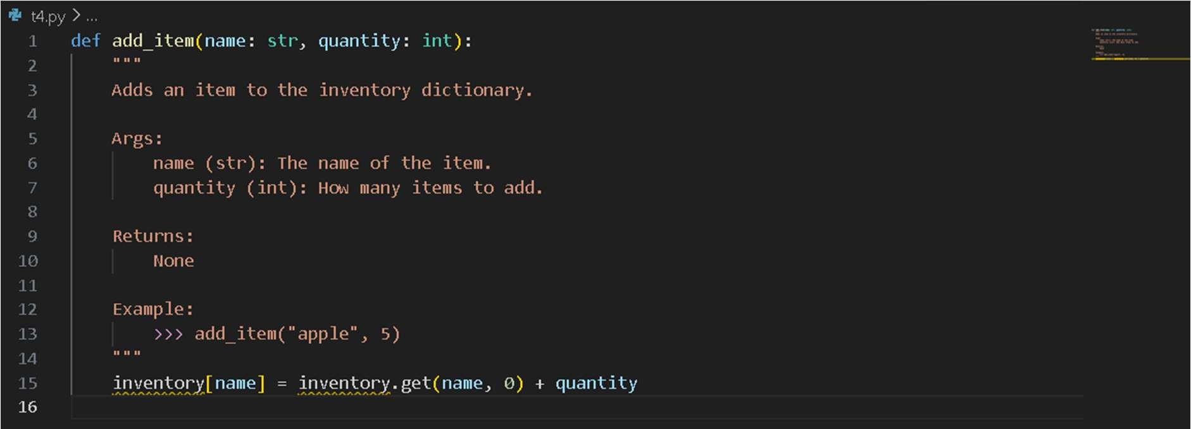
Task Description #5 (Documentation – Review and Correct Docstrings)
- Task: Use AI to identify and correct inaccuracies in existing docstrings.
- Instructions:
- Provide Python code with outdated or incorrect docstrings.
- Instruct AI to rewrite each docstring to match the current code behavior.
- Ensure corrections follow Google-style formatting.
- Expected Output #5:
- Python file with updated, accurate, and standardized docstrings.

Prompt:
I have Python code with outdated or incorrect docstrings. Please review the code, correct the docstrings to accurately describe the functions/classes, and rewrite them in Google-style formatting.

Code with outdated docstrings :
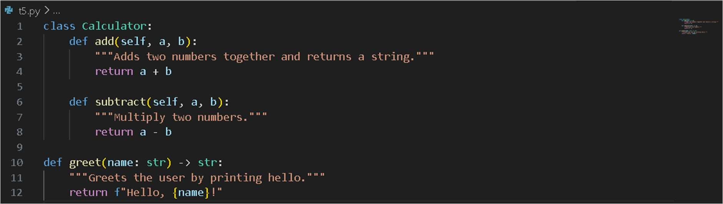
Updated code:
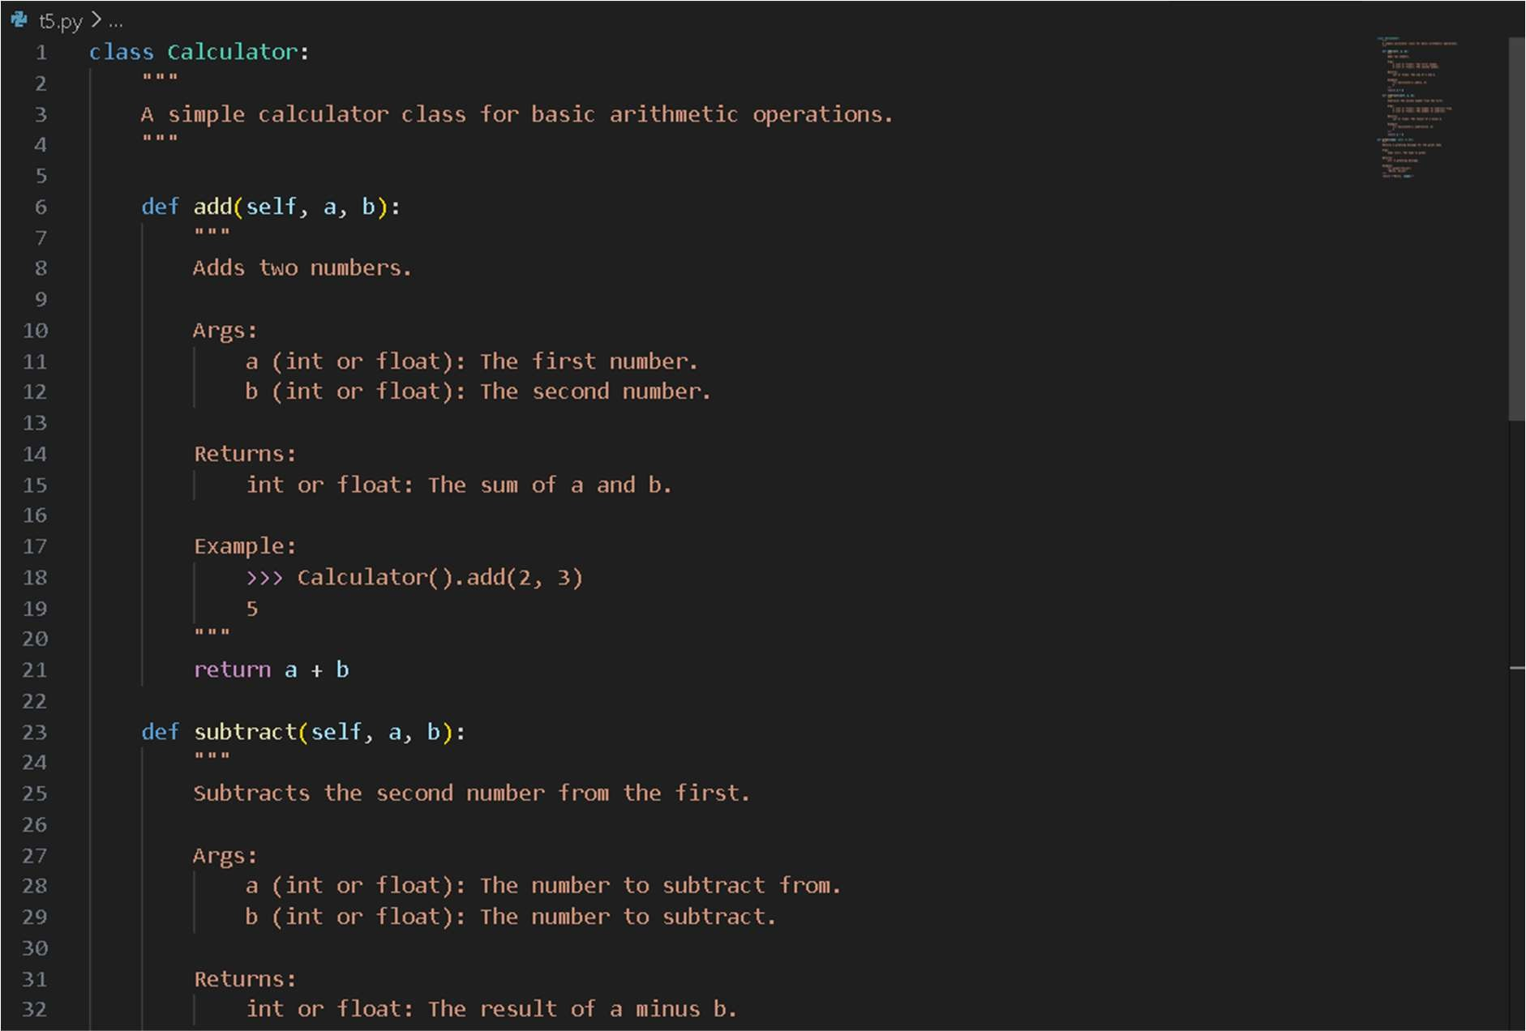
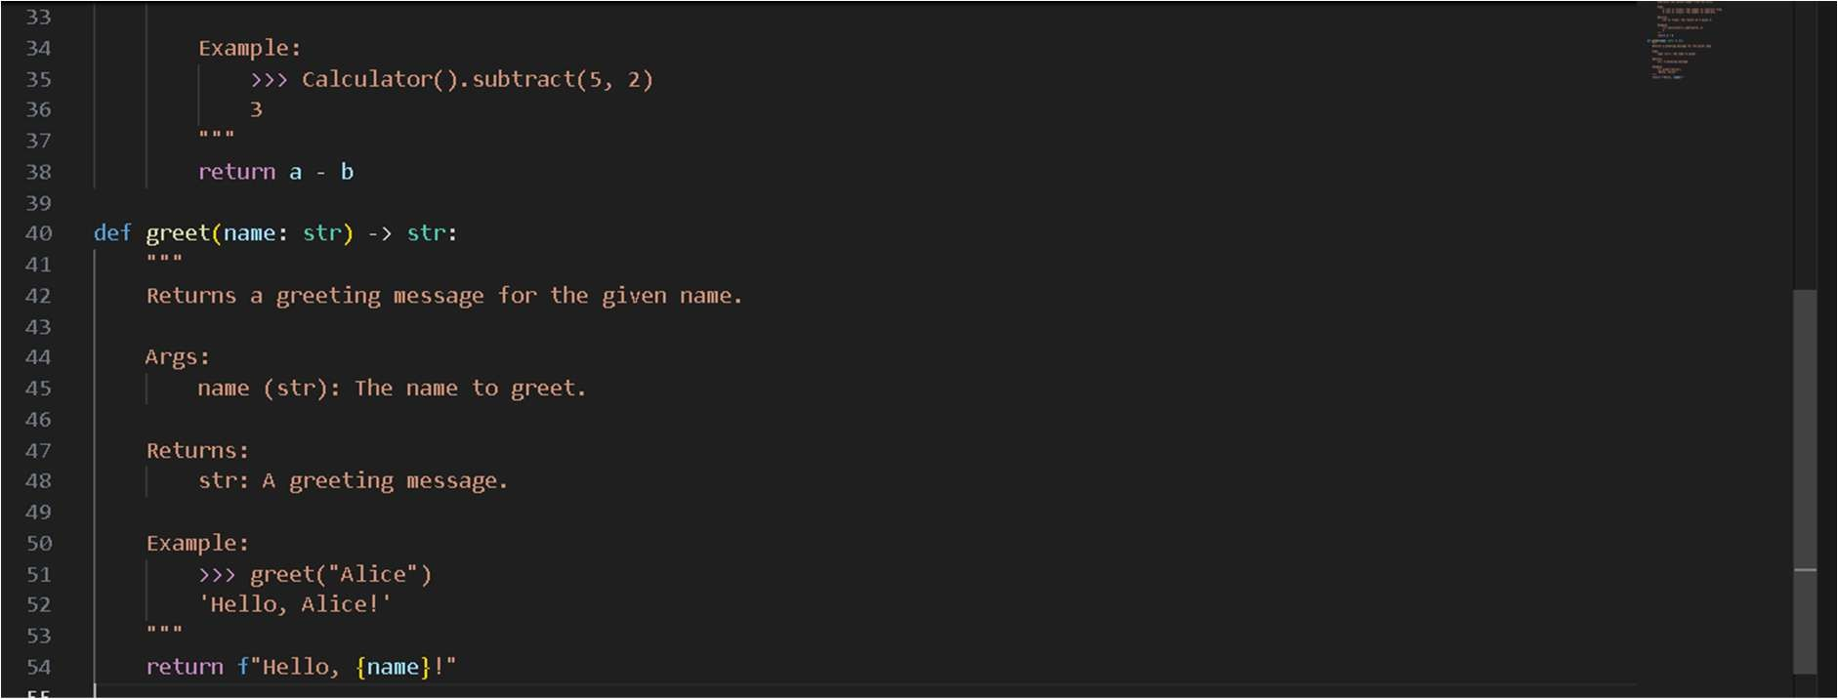

Task Description #6 (Documentation – Prompt Comparison Experiment)
- Task: Compare documentation output from a vague prompt and a detailed prompt for the same Python function.
- Instructions:
- Create two prompts: one simple (“Add comments to this function”) and one detailed (“Add Google-style docstrings with parameters, return types, and examples”).
- Use AI to process the same Python function with both prompts.
- Analyze and record differences in quality, accuracy, and completeness.
- Expected Output #6:
- A comparison table showing the results from both prompts with observations.

Vague Prompt:
Add comments to this function.

Code for vague prompt:
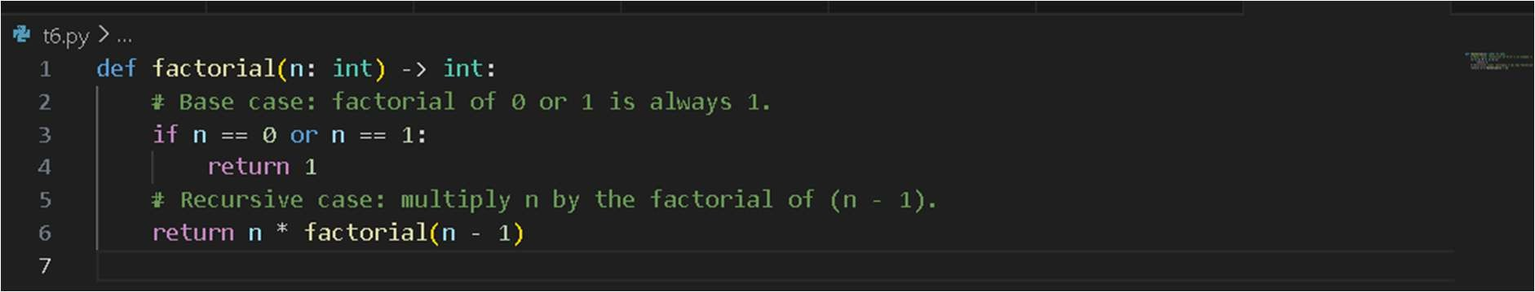
Detailed Prompt:
Add Google-style docstrings with parameters, return types, and examples.
Code for detailed prompt:
